AS BADMITON - Compétition INDIVIDUELLE DISTRICT
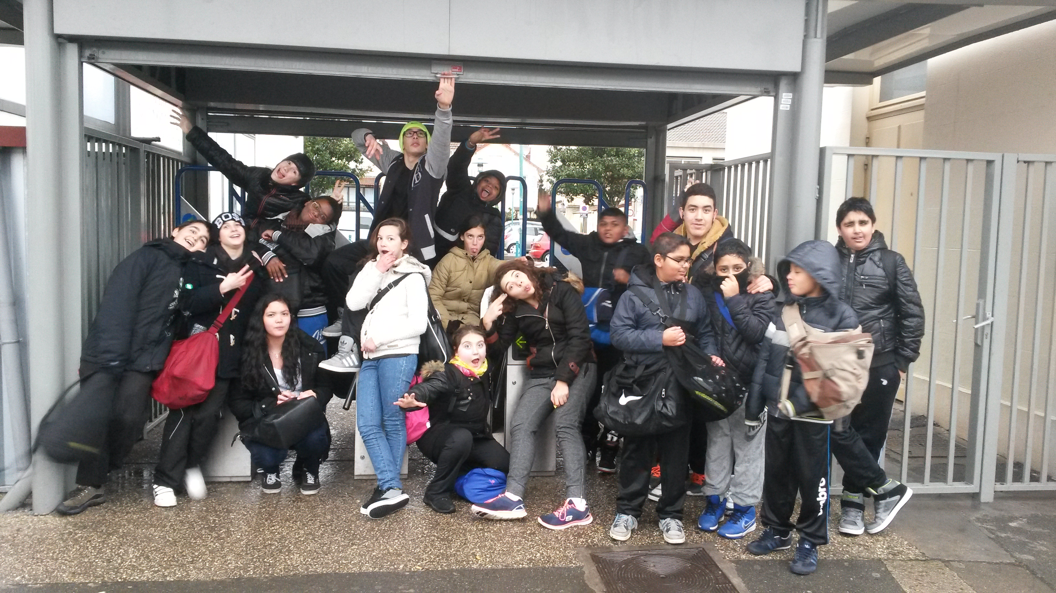

BENJAMINS /29
BENJAMINES /19
1 | FLOURY | LAURA
3 | LEFEBVRE | MARIE
8 | BOULACHEB | OCEANE
12 | BORGES | LUANA

4 | SAGNY | WILHEM
8 | RIJAL | AYOUB
16 | DE FILLIPIS | LORELAN
17 | VICKNARAJAH | FELICIEN
25 | GHANI | SAMIULLAH
27 | DA SILVA | FABIEN
28 | KUMAR | KARTIKAY
MINIMES FILLES /23
6 | CAO | ELYNA
19 | MPONDO | SOPHIE
22 | EL AMRAOUI | LYNDA

MINIMES GARCONS /34
8 | POUZERE | henry
10 | GRARD | gaël
14 | THIBAUT | medhi
15 | DOMINGO | Fredah
22 | AMARAL | alexis
24 | GOMES | luis
25 | BOUTCHICH | nabil
27 | BORGES | luis
29 | MAROUDAY | lucas
32 | AMER | anfal
BRAVO A TOUS !

Qualifiés pour les départementales excellences : Willem, Laura, Marie !

Qualifiés pour les départementales excellences : Ayoub, Océane, Luana, Henry, Gaël, Mehdi, Fredah, Elyna !

